Part 3

The directions for part 2 were outdated, so the following will be a tutorial for the current version of part 2. The goal of this tutorial is to create an app that has two maps side by side within AppStudio and QT.

Step 1. Open AppSudio.

Step 2. Click “New App” in the upper left

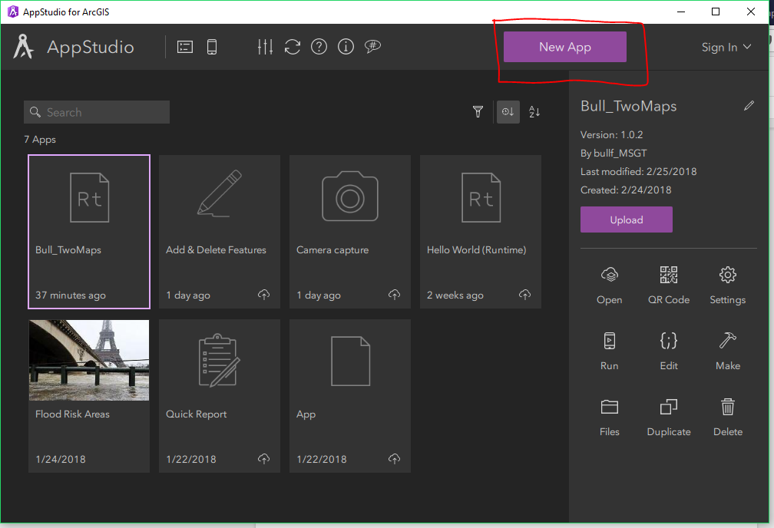

Step 3. Click on “Hello World (RunTime). Then click “Create”

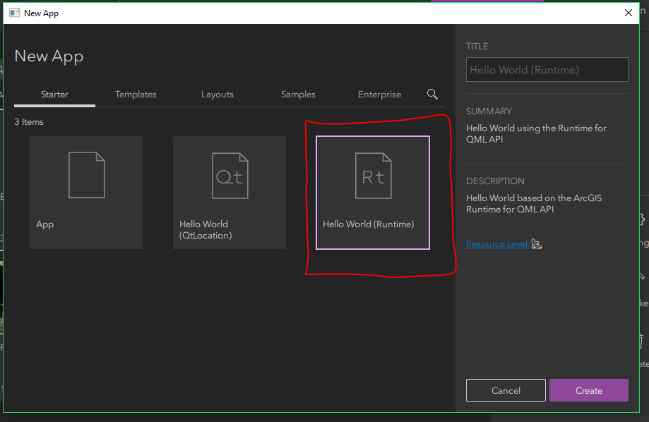

Step 4. Let's change the title of the map. Click on “Hello World”, then click the pen in the upper right hand corner. Change the Title to whatever you want to call it. Then click on the check mark ( it replace the pen in the upper right hand corner) to save the title.

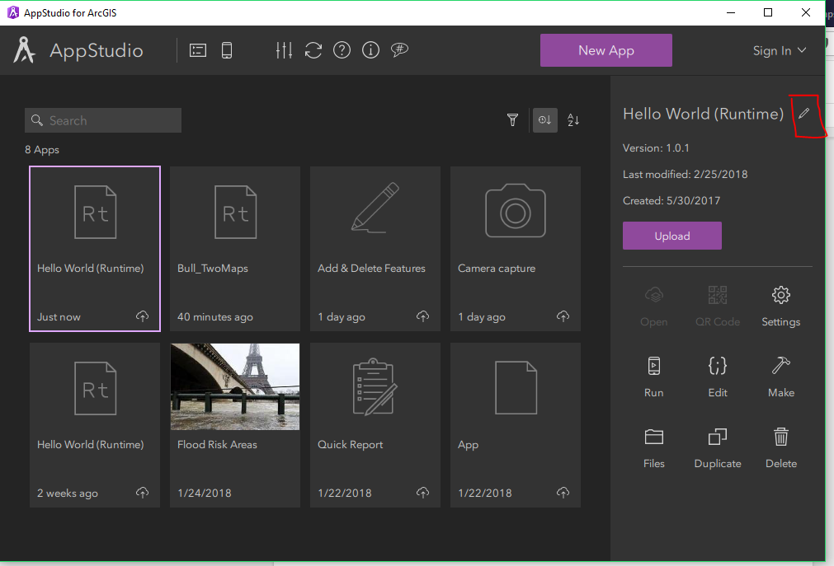

Step 5.

Let’s change the base code for Hello World. Click on edit in the right hand side. This will open QT.

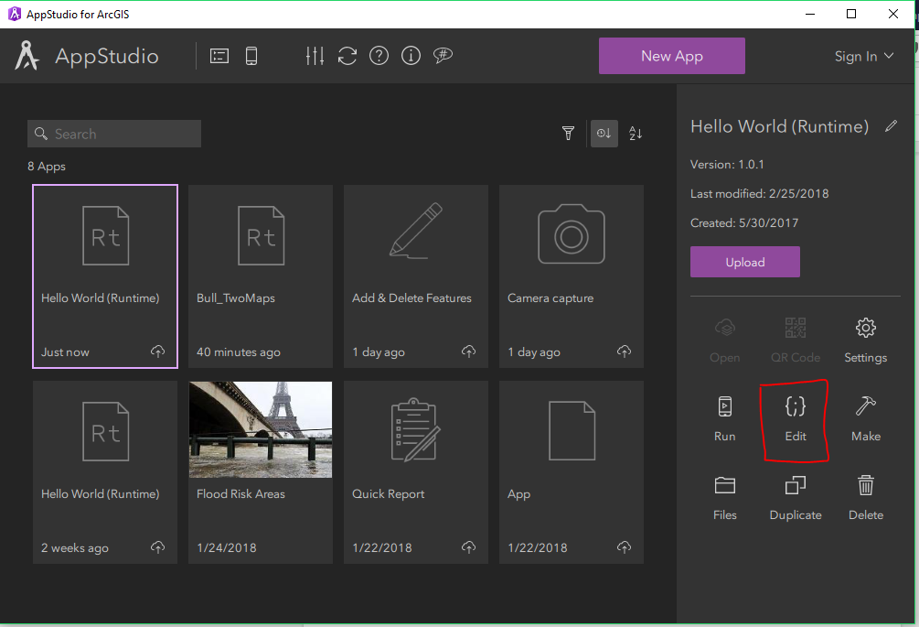

Step 6.

Within the MyApp QML after line 161 add a new line. Ignore the red horizontal lines next to the line numbers. These will go away once you save the qml.

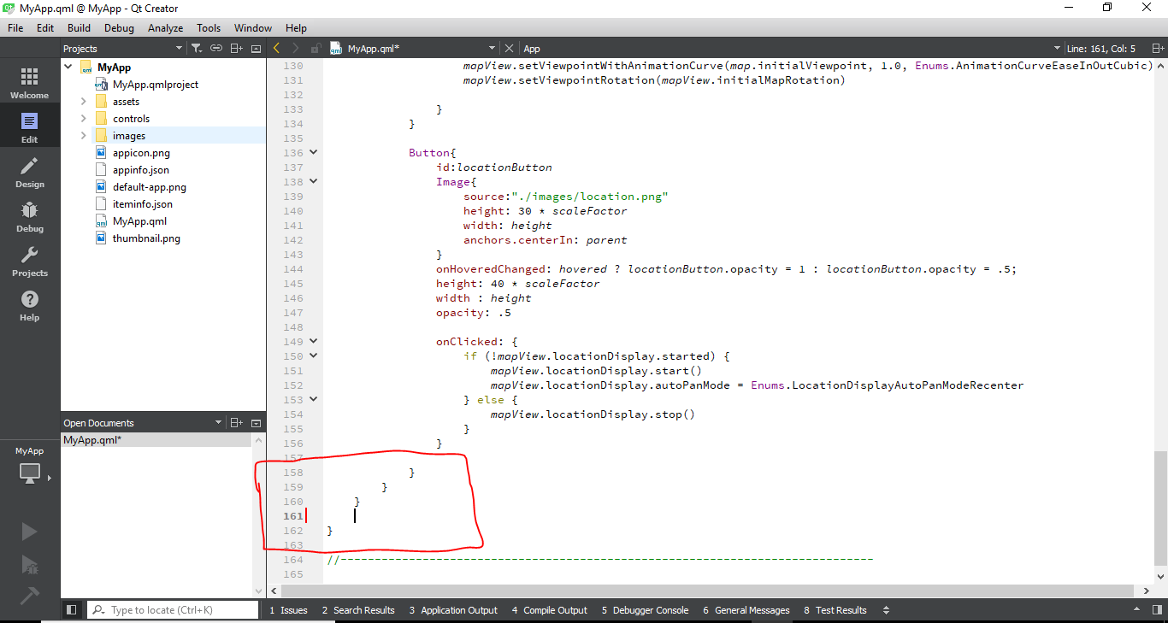

Step 7: copy lines 68 to 160 and paste it into line 161.

Step 8: We will need the change the id within the new MyView we copied over. Lines 162, 182, 187, 199, 208, and 230 will have to change to a unique id, See below. It can be as simple as adding a 2.

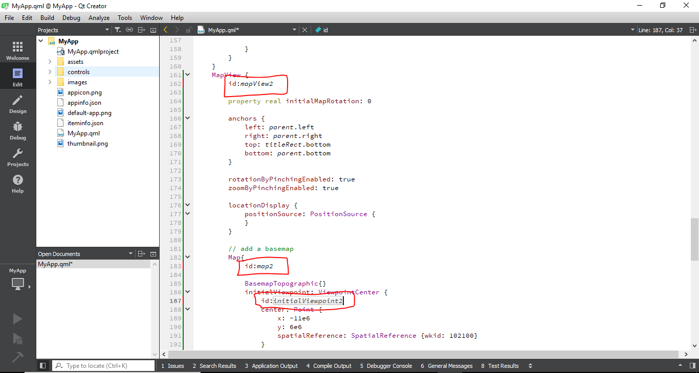

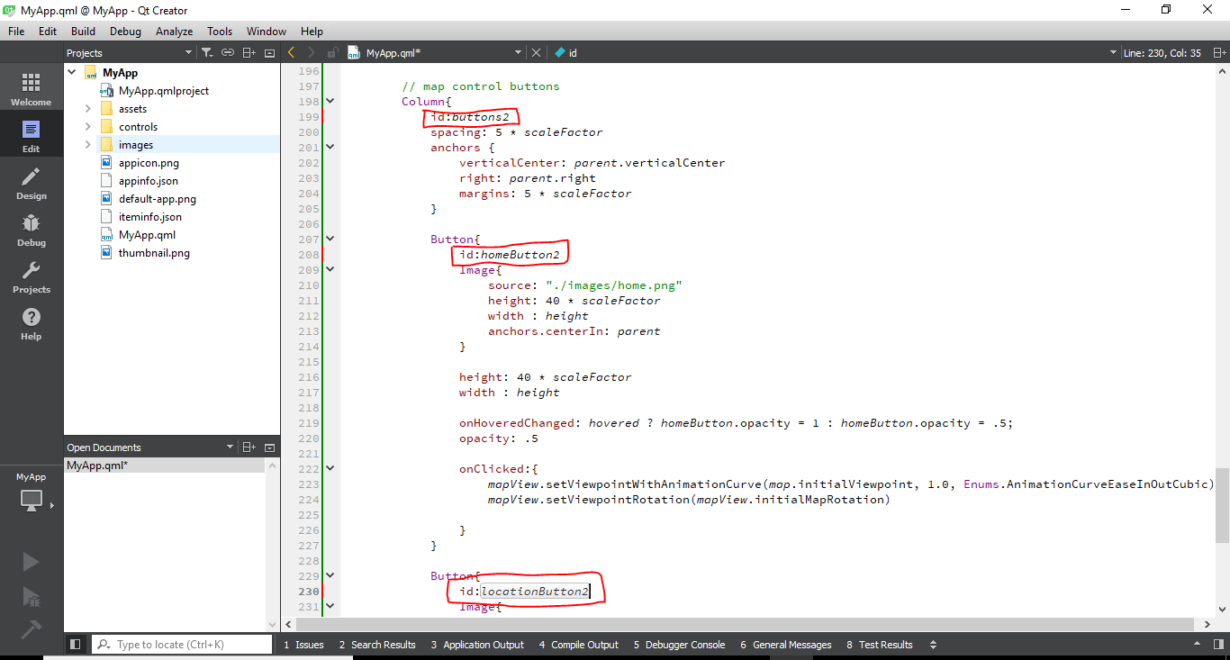

Step 9: We will now split the two screens. WIthin the first MyView, comment out line 75. Then add width: parent.width \* 0.5 after line 78.

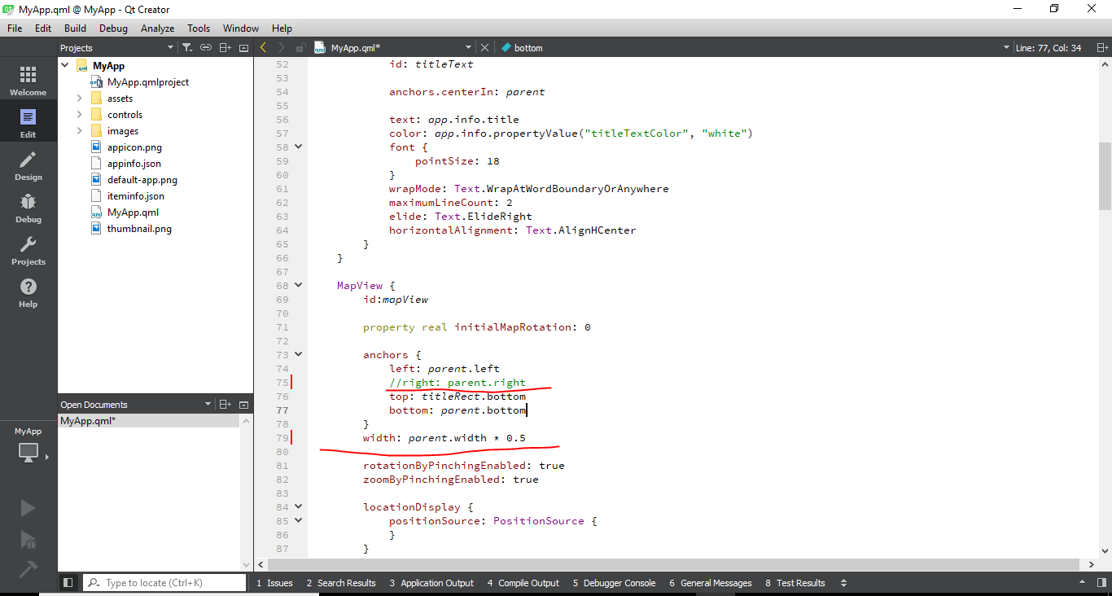

Step 10. Repeat the step 9 within the second MyView with a couple of changes. Comment out line 168. Then add width: parent.width \* 0.5 after line 173.

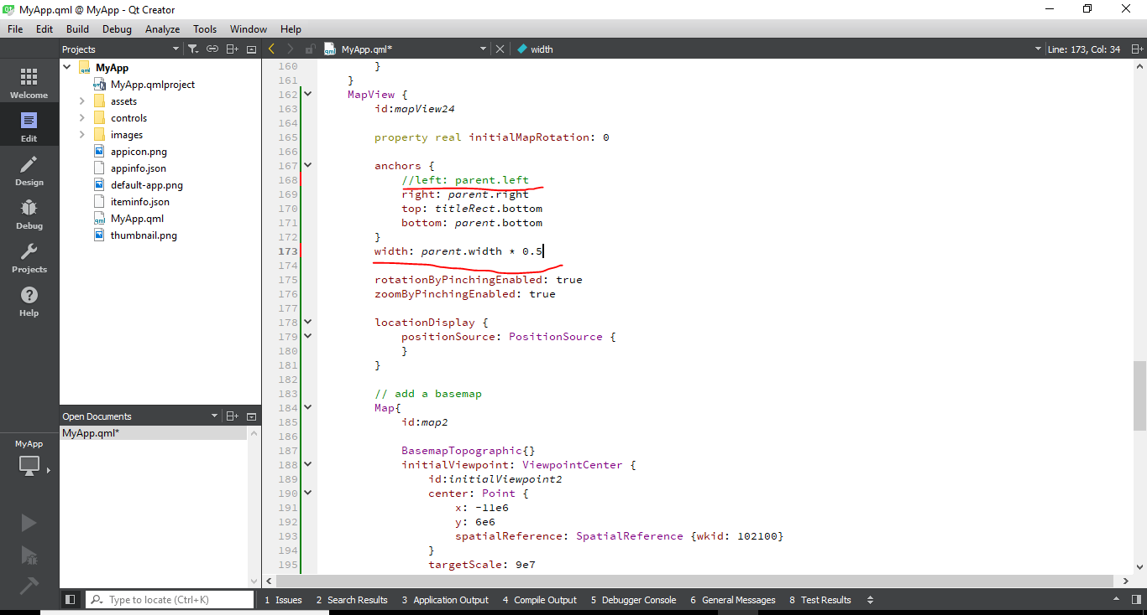

Step 11. We will now change the basemap of each map. Go to following link to see the basemap options. <https://developers.arcgis.com/qt/latest/qml/api-reference/qml-esri-arcgisruntime-viewpointextent.html>

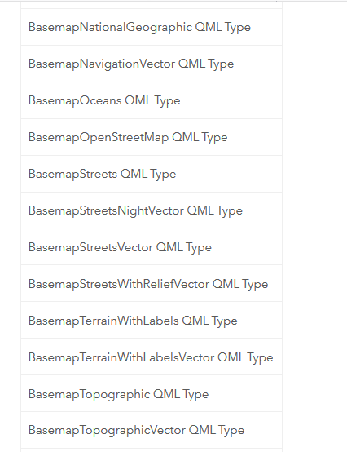

Step 12. Copy the title of basemap into line 93 to change the basemap of the left map and line 187 to change the basemap of the right map.

Step 13. Save the QML.

Step 14. Open the app within the AppStudio.

Within the new code extent does not work. I have been unable to find a solution yet. This is very frustrating.